How to set up VPN in Windows 10?



Windows 10 makes it easy to set up and use a VPN on your computer. Below you will find instructions on how to set up a VPN in Windows 10.

👨 Setting up a VPN in Windows 10

A VPN service allows you to protect your privacy by allowing you to browse the web anonymously from a remote location.

To use VPN on your computer, you first need to find a good VPN service provider and subscribe to their services.

After signing up with a VPN service provider, you need to collect the following information.

1. The web address or IP address of the VPN server
2. Your VPN username and password
3. Other special requirements (if any)

While the VPN username and password will be required to authenticate your connection to the VPN service.

👨 Steps to set up a VPN in Windows 10

If you have the information needed to set up a VPN network, you can follow these steps to set up a VPN in Windows 10.

1. Open Settings on your computer and click the Network and Internet tab.

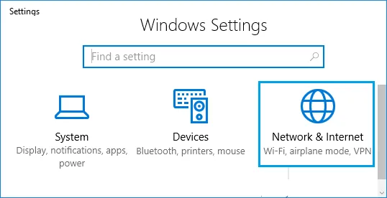

2. On the next screen, click VPN in the left pane. In the right pane, click the Add VPN Connection option located in the VPN section.

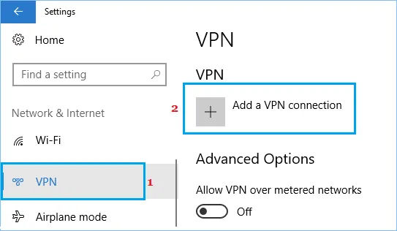

3. The next screen asks you to provide details about your VPN connection. For simplicity, we have split the screen into two parts.

In the first section, you will need to provide information about your VPN provider, VPN connection name, VPN server address, and VPN connection type.

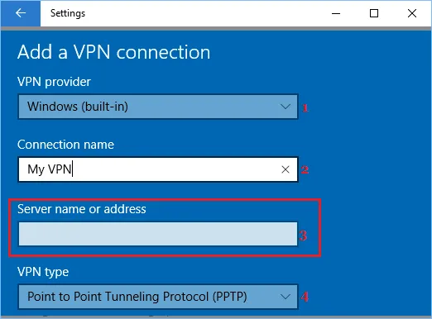

VPN Provider: Select Windows (built-in).

Connection Name: enter any name you can think of.

Server Address: here you will need to enter the web address of your VPN server (www.yourVPN.com).

VPN Type: select Point-to-Point Tunneling Protocol (PPTP) or any other option recommended by your VPN provider.

After providing the above information, scroll down and provide more details about your VPN connection.

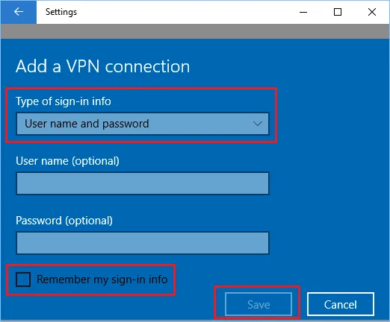

Login Data Type: Select a username and password as the method you will use to log in to your VPN. You can also choose from other options if recommended by your VPN service provider.

Username: This is optional.

Password: Optional.

If you have provided a username and password, you can select the Remember my login details option.

This will cause Windows 10 to remember your username and password, allowing you to log on to the VPN network without entering your username and password.

5. After providing all the details, click Save to save these settings.

👨 How to connect to a VPN in Windows 10

Once your VPN network is set up, you can connect to your VPN network using settings or directly from the taskbar.

1. Click the network icon located in the far right corner of the taskbar, and then click the name of your VPN network in the menu that appears.

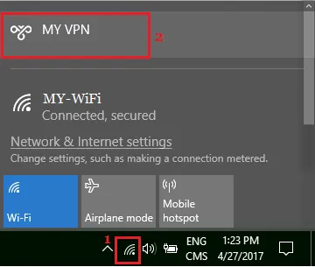

2. On the next screen, you might be asked to enter your VPN username and password to log in to the secure VPN network.

Another way to connect to a VPN-access the Options menu in Windows 10.

1. Open Settings on your computer and click the Network and Internet tab.



2. On the next screen, click VPN in the left pane. In the right pane, click your VPN name, and then click the Connect option.

As you can see from the image above, connecting to the VPN from the options menu also gives you access to additional properties.

How do I access the VPN properties?

Navigate to the Network and Internet page. The Network and Sharing Center will appear. The left pane will lead to the Change Adapter Settings link. Selecting the Properties option when right-clicking on the VPN adapter will allow you to view its properties.